Testing Steps for Dev Environment
7. Process Schedules
[Note: This step is directly depend on process steps step]
1. Process Schedules
Here you can see already created process schedules and also create new one
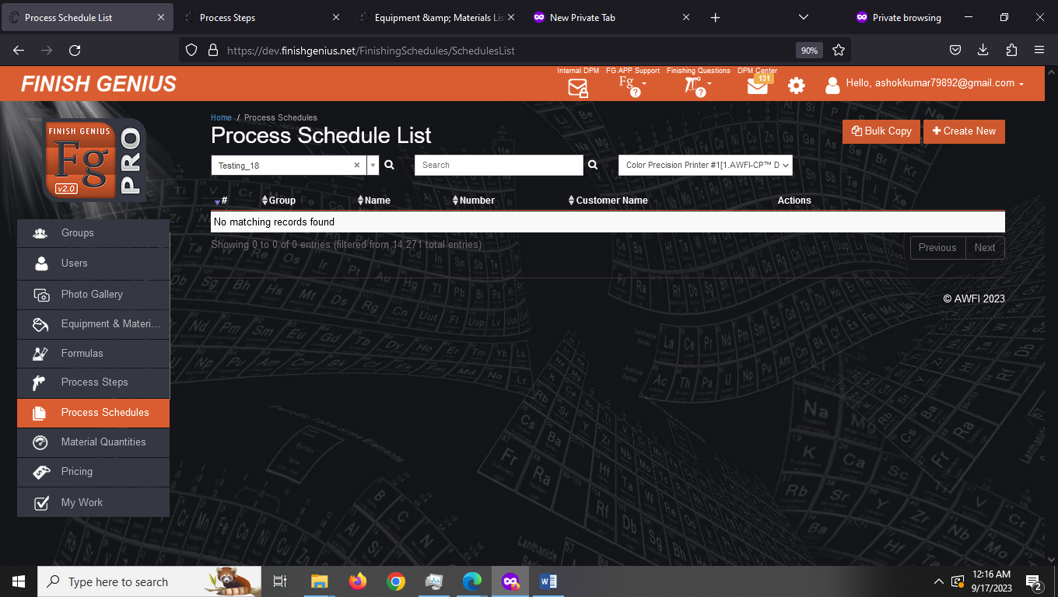
2. Creating New Process Schedule
Suggestion: There should be Back button on Create New Schedule Step
Step 1. Click on Create New
Step 2 Give Name, Schedule Number and Customer Name to this particular Schedule .
Select and arrange process steps to schedule
Click on save
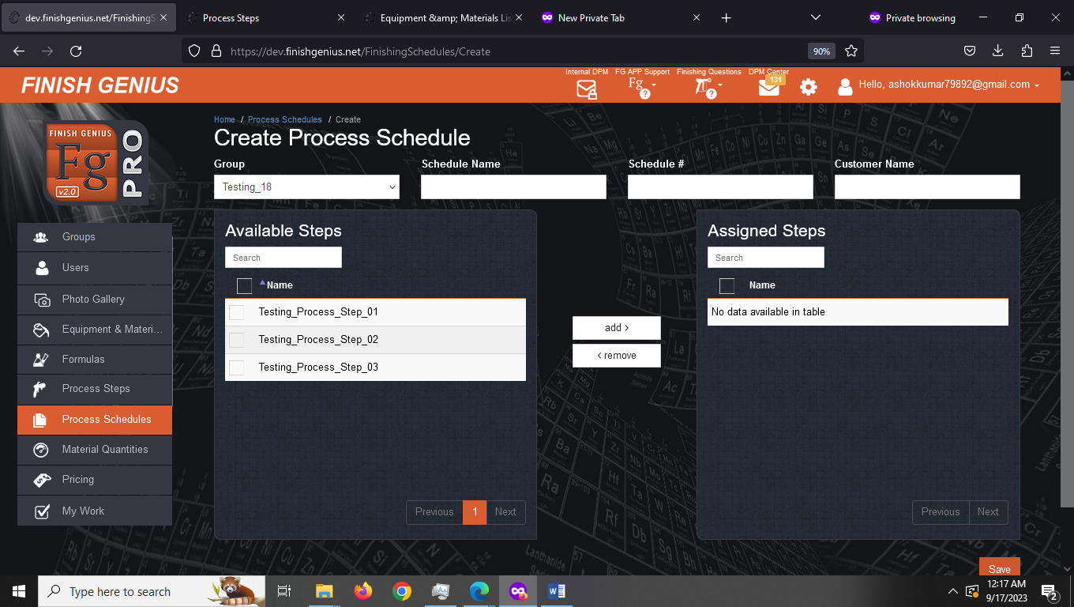
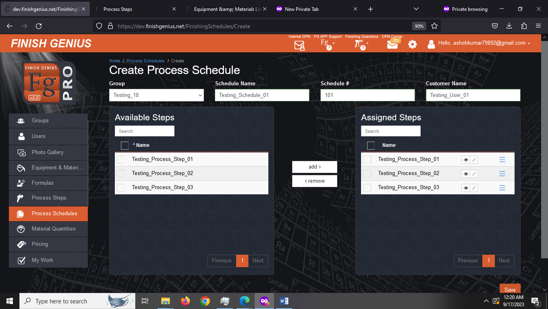

Step-3: You can also print this schedule
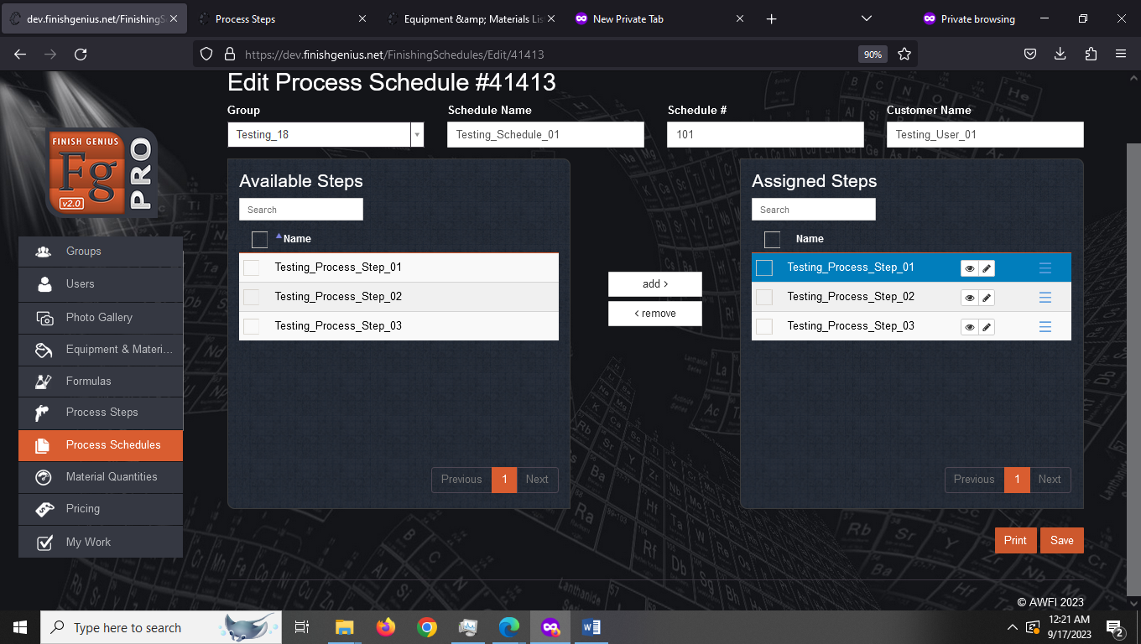
Step 4 You can edit each schedule
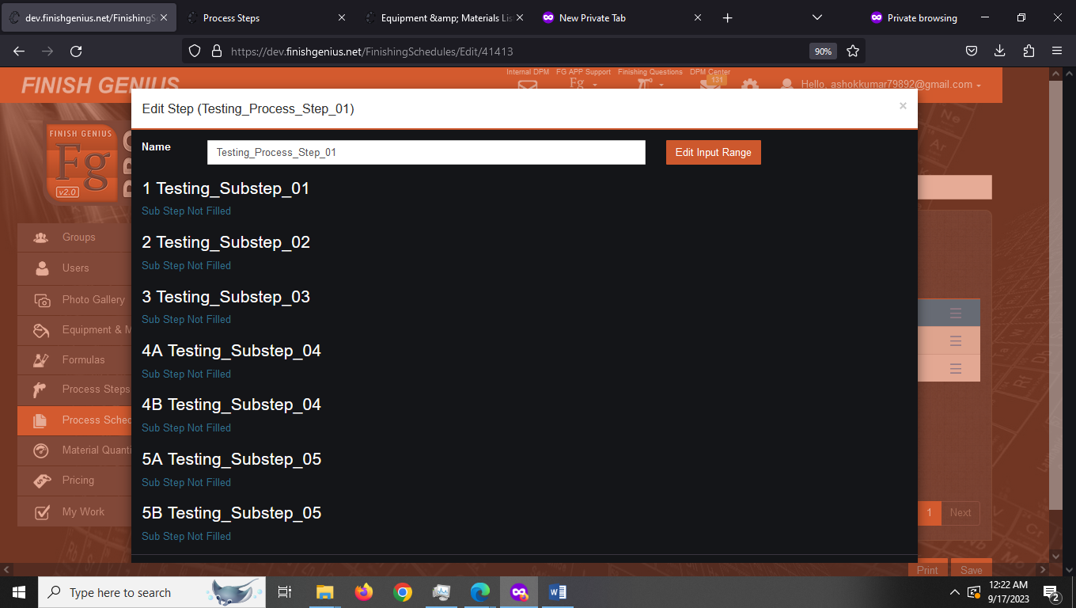
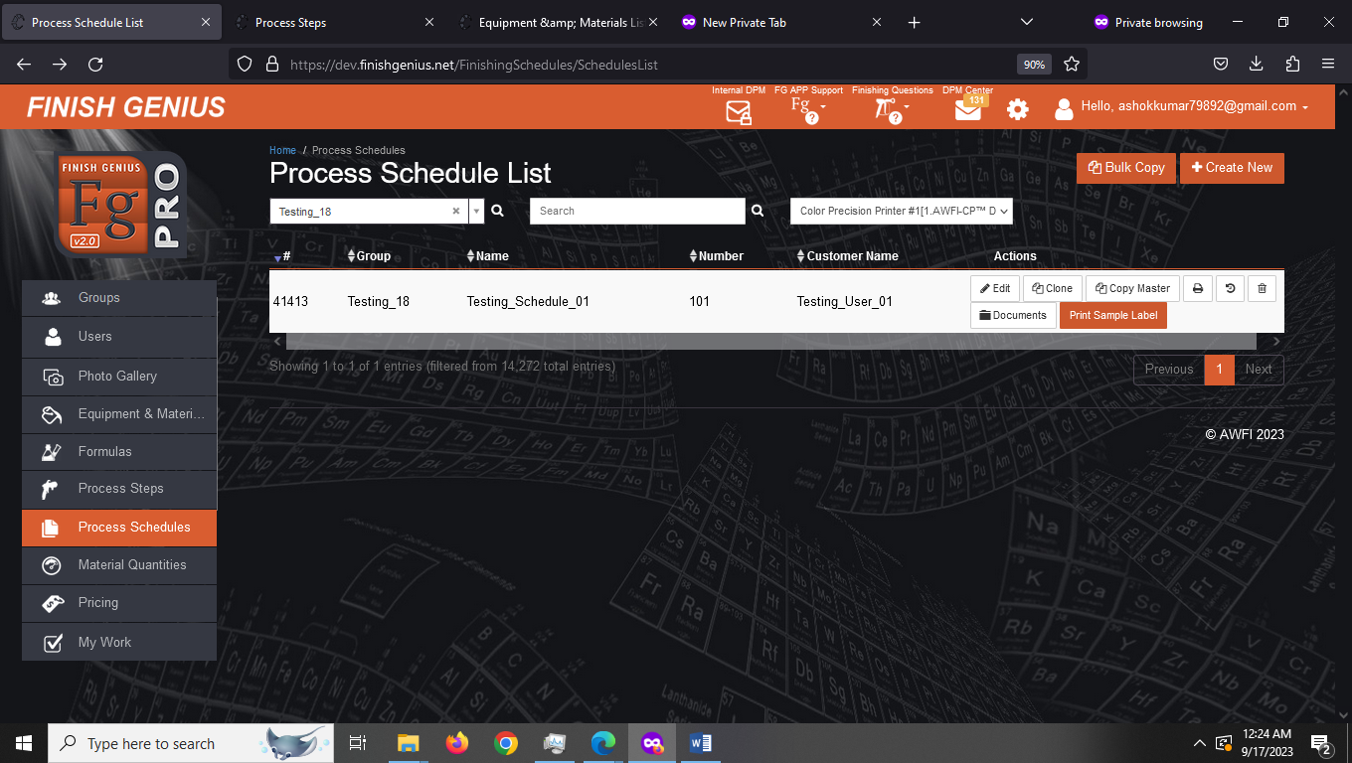
3. Bulk copy
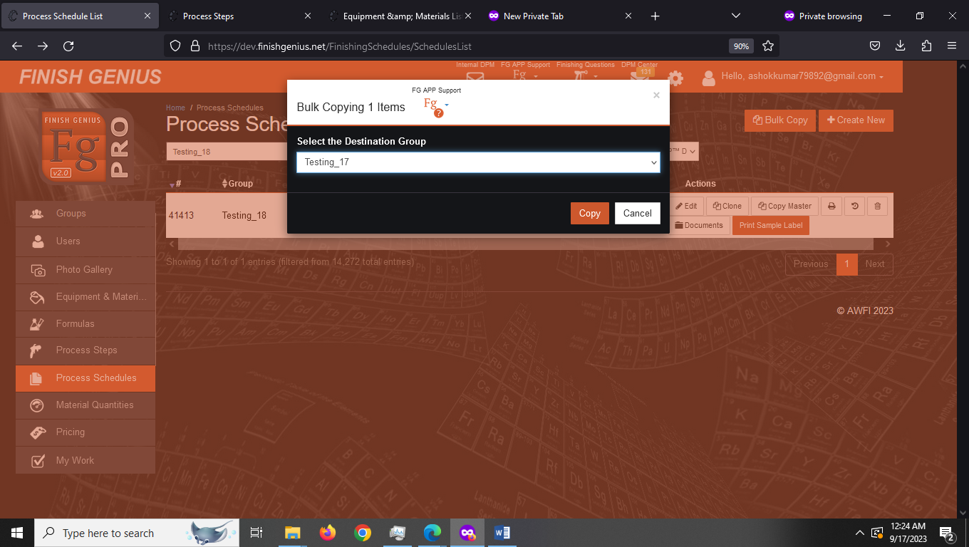
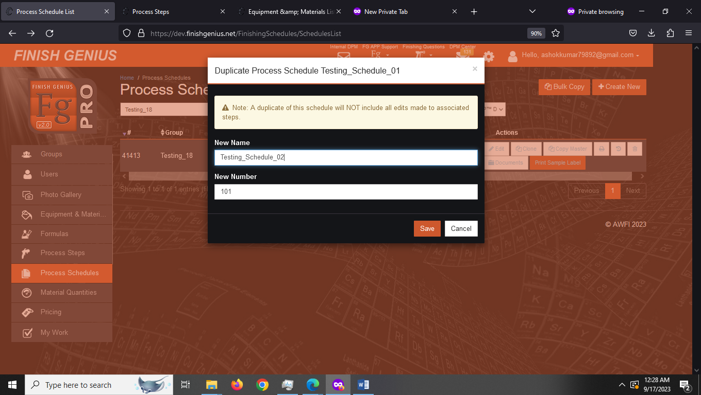
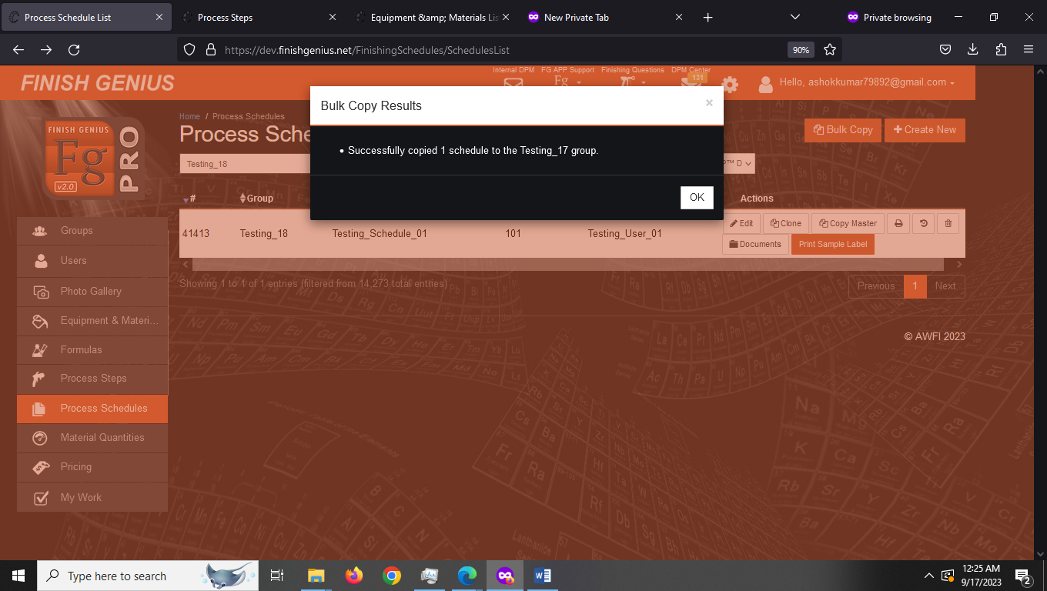

4. You can create other process schedules from the existing process schedule by using clone feature
Note: all the edits made to this process schedules doesn’t get copied
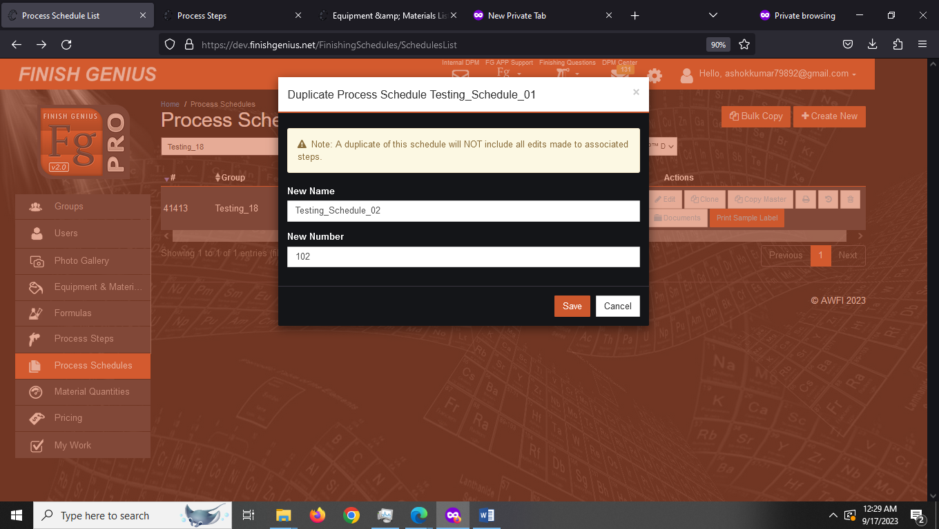
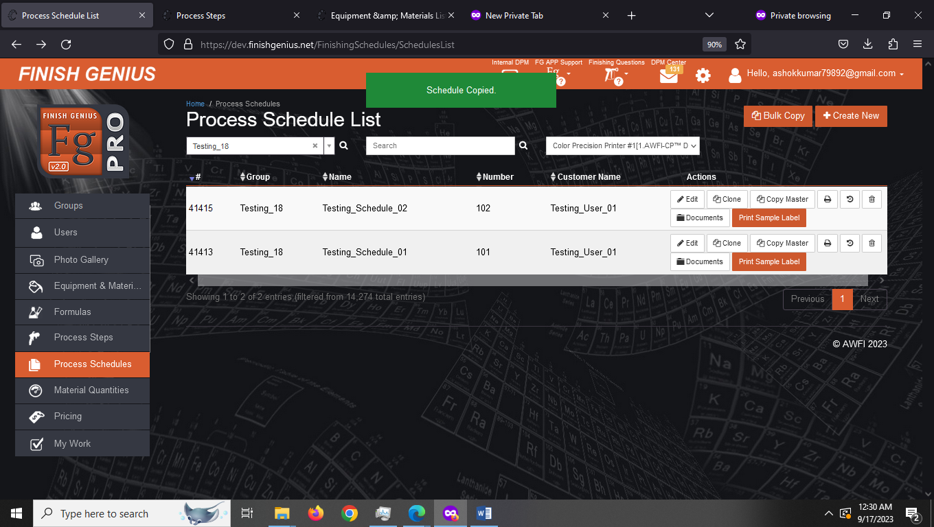

5. You can copy the schedule to other schedule (and also want to include all the edits made then you can use master copy)
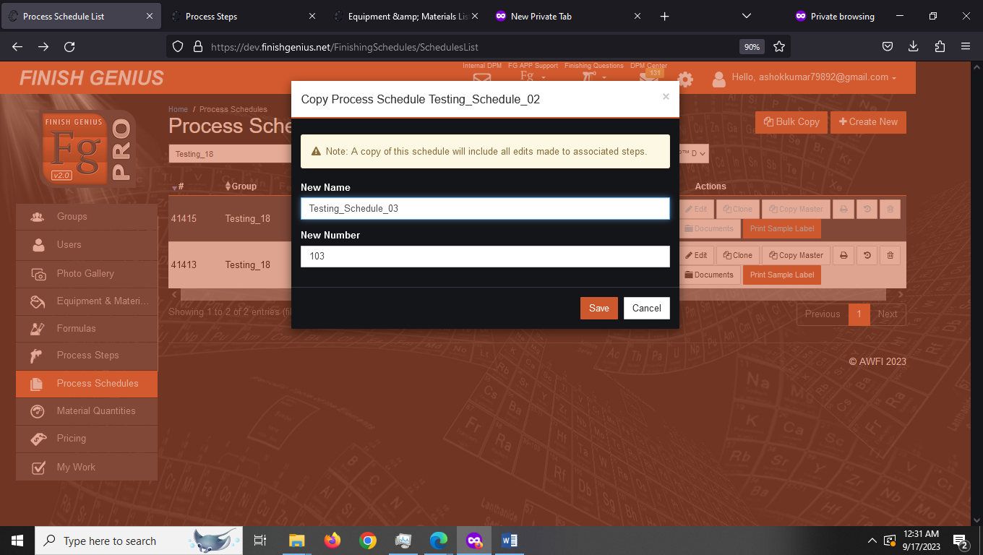
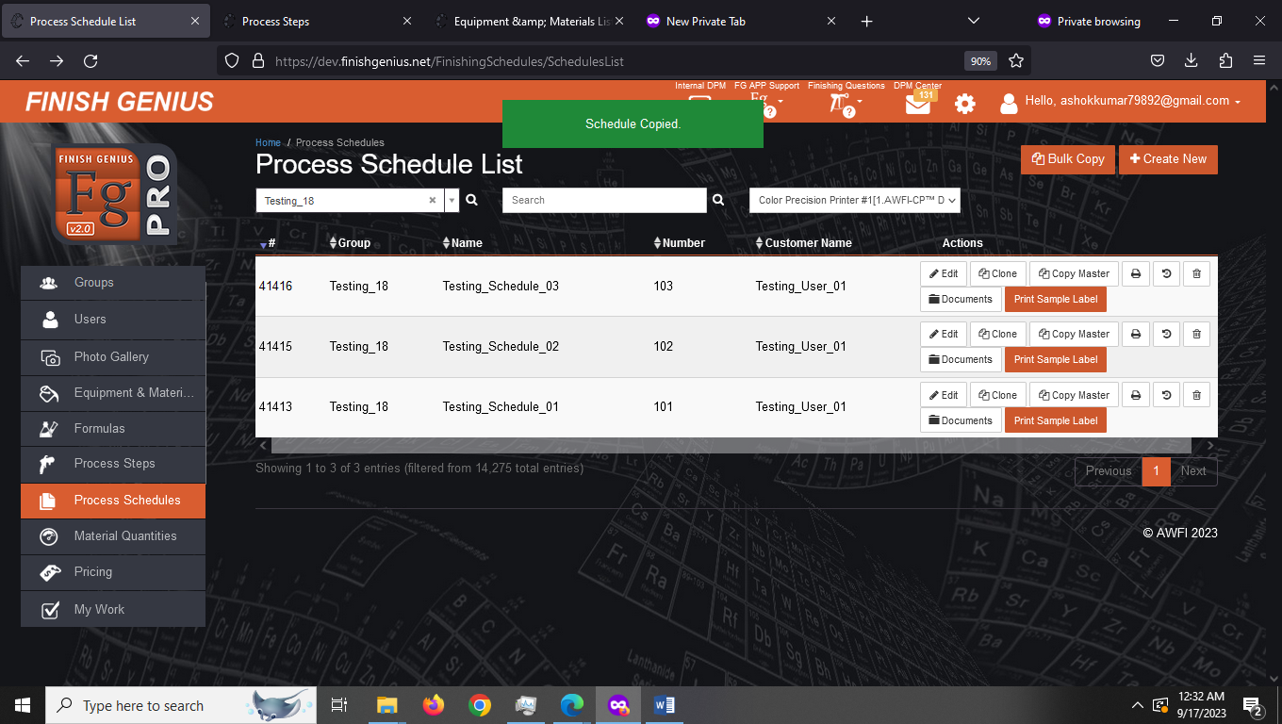

6. You can also view, print and see history of schedule and archive the schedule

Conclusion
1. Process Schedules for selected client is visible
2. We are able to create New Process Schedule
3. We are able to edit existing process schedule
4. We are able to bulk copy process schedule to other group
5. Clone & Copy master are working properly
6. History and Archive and print sample label option need to be tested

